I started by creating Slice and before that I created a token (id_token.json) and uploaded in the folder 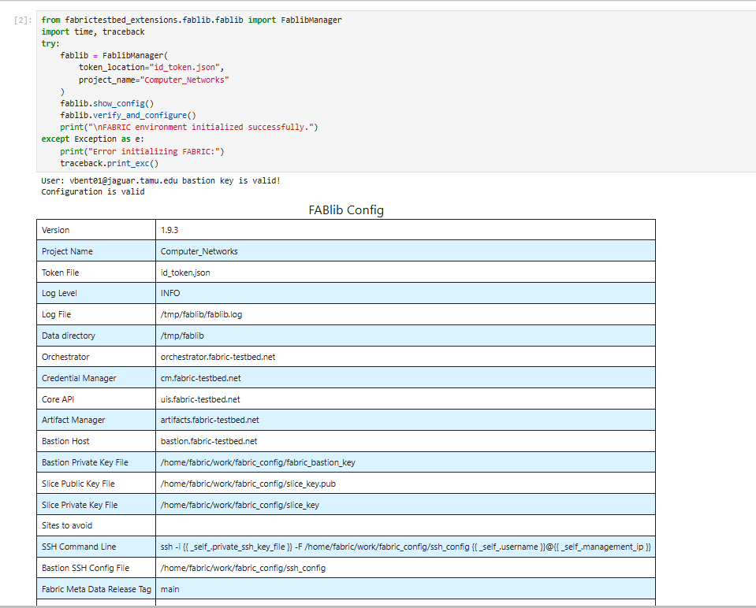
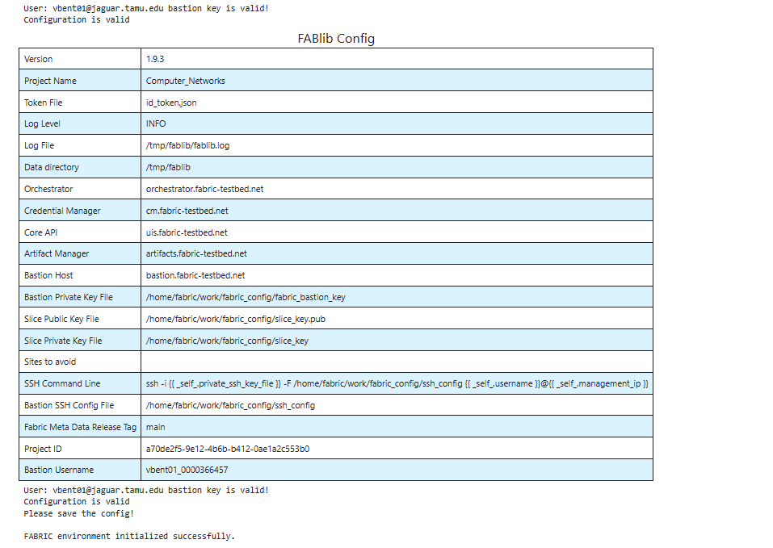

Now we define the slice and submit it.
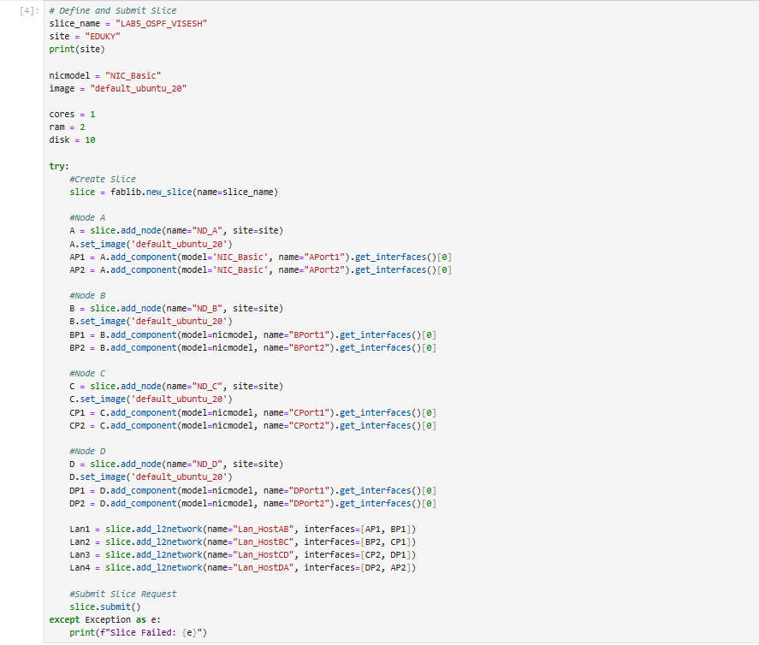
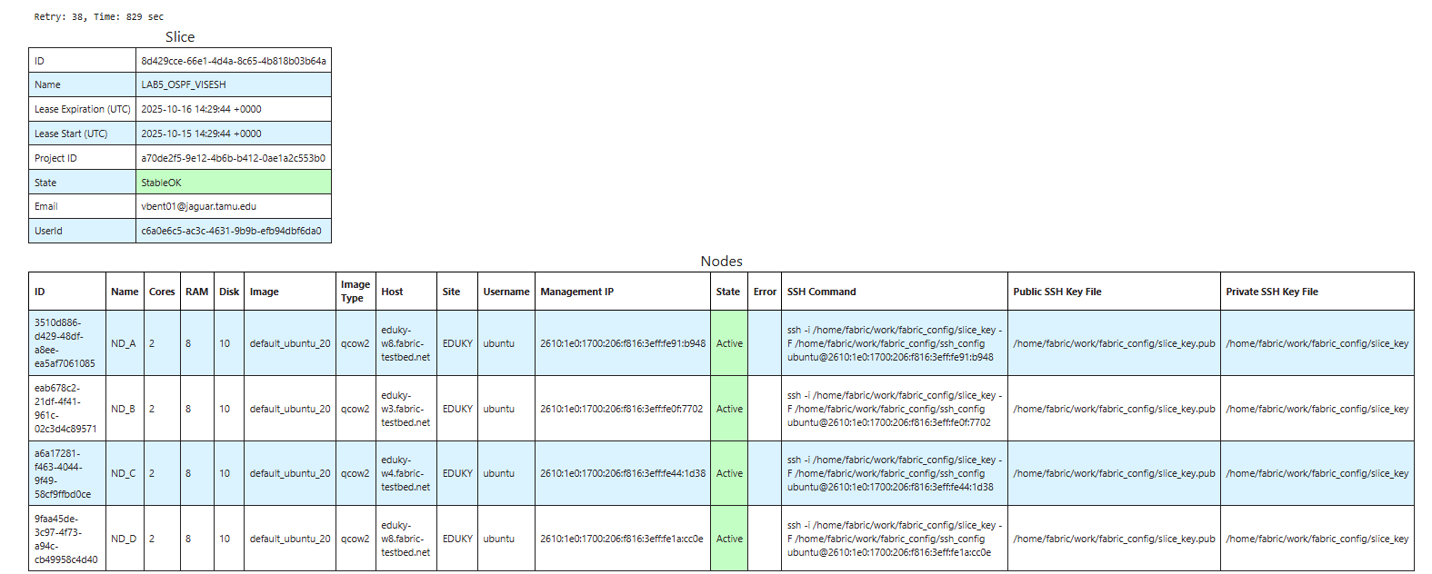
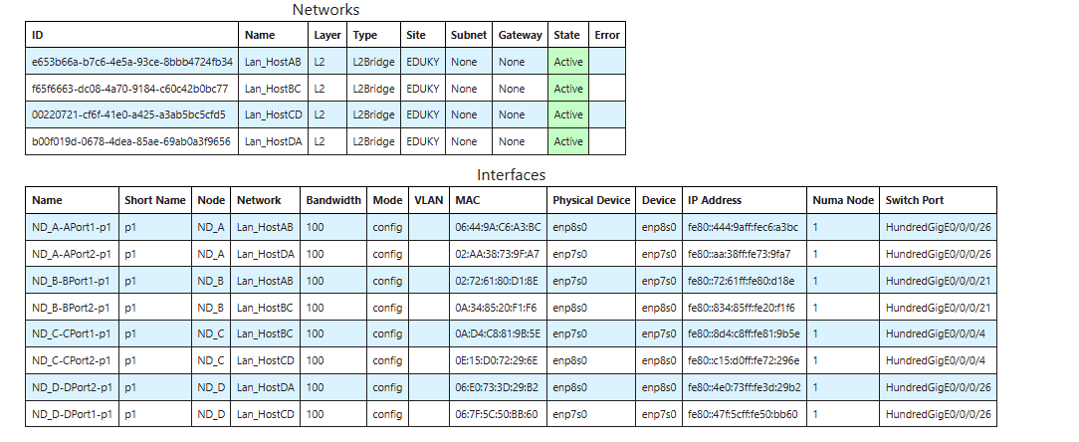
Topology
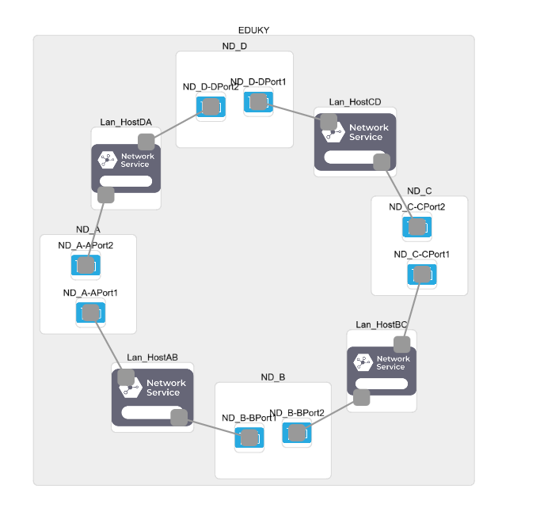

To confirm the slice name and details
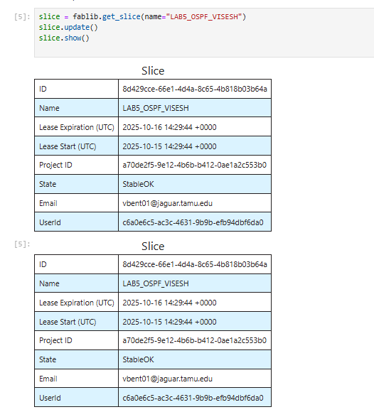
And we setup network
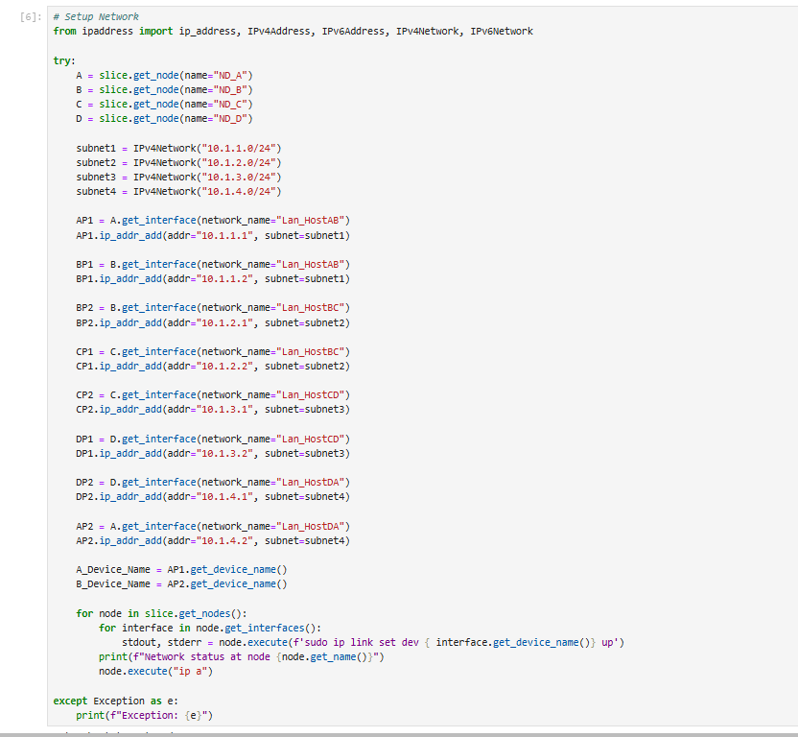
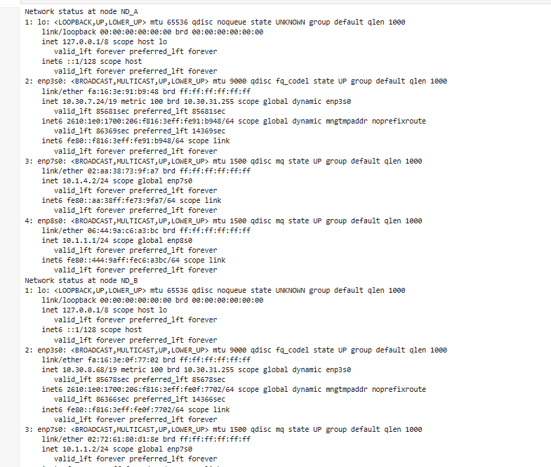

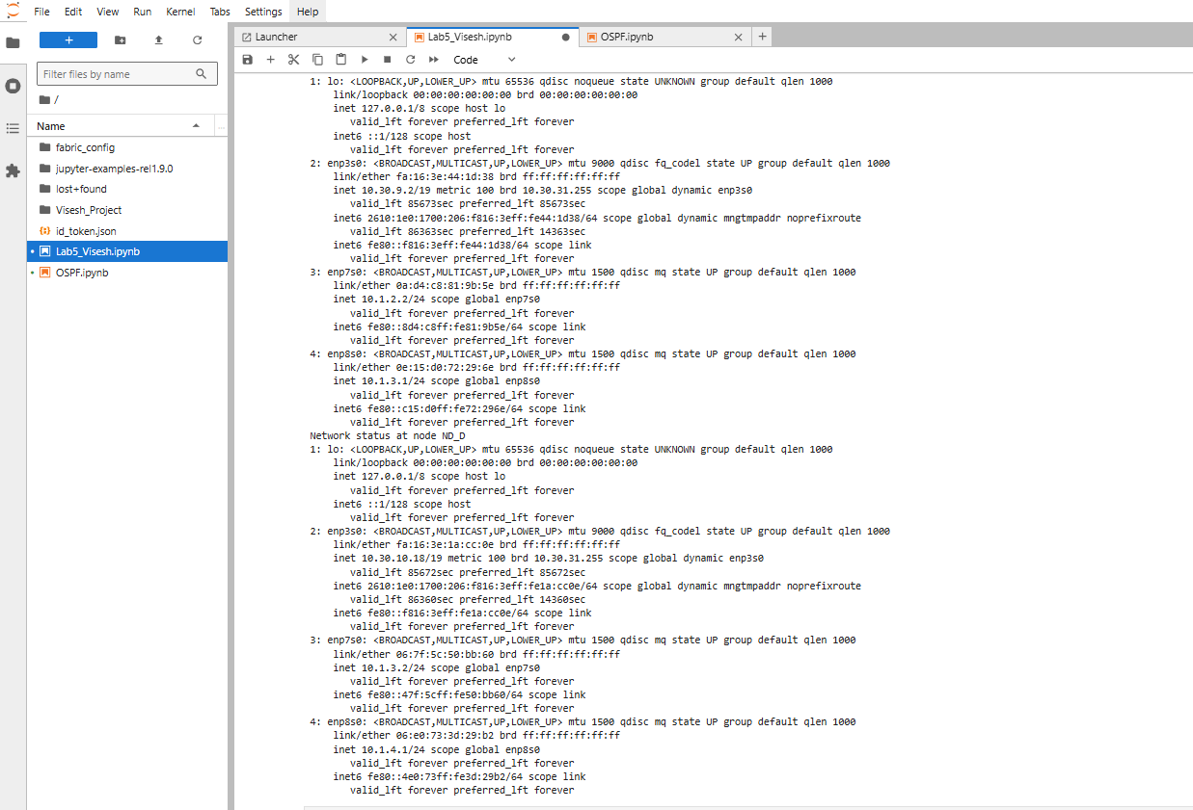
After that we setup interface
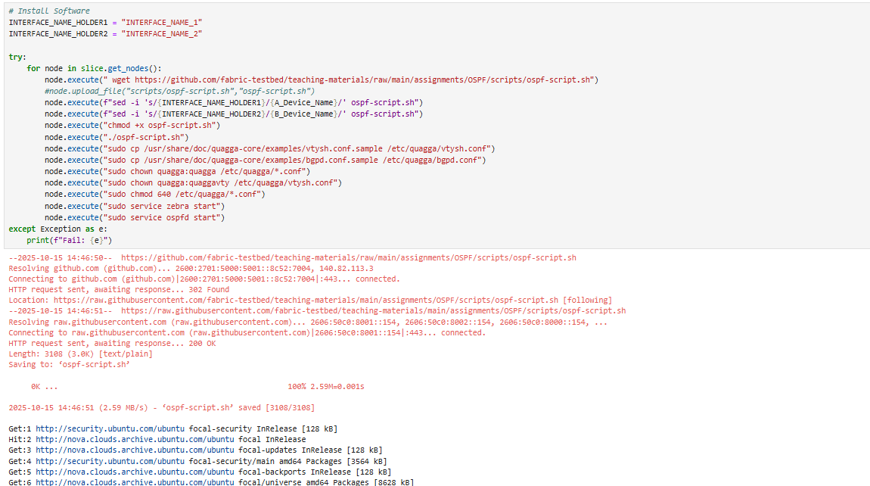

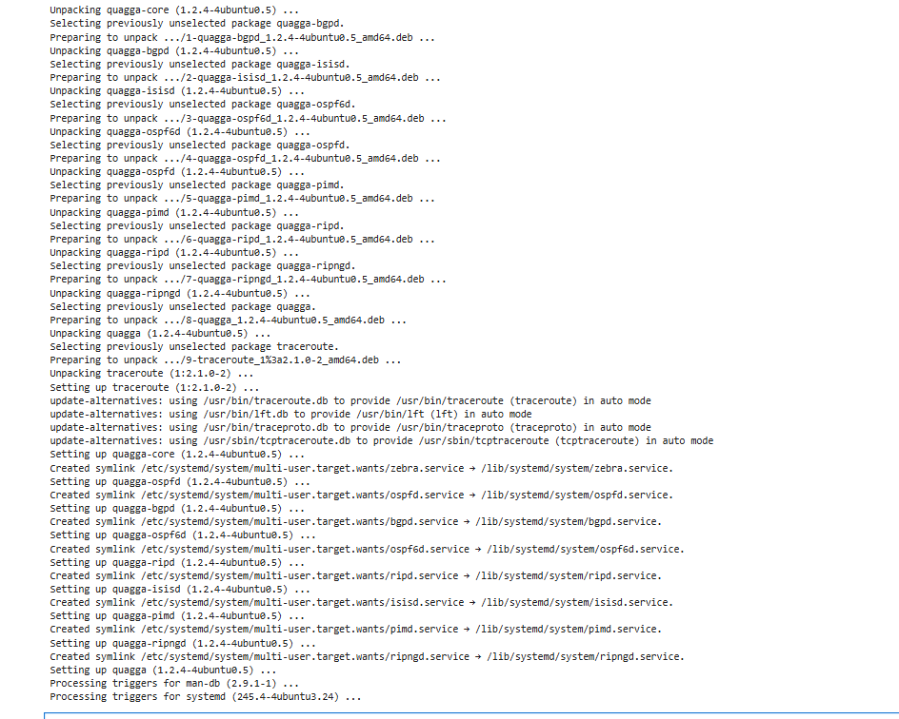
Then we go to the ospf.ipynb for the rest of the experiment and this is what and ospf looks like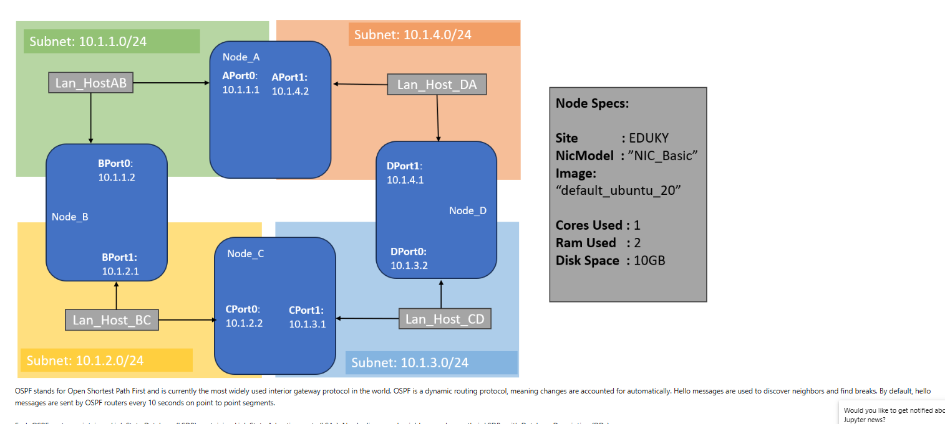
OSPF stands for Open Shortest Path First and is currently the most widely used interior gateway protocol in the world. OSPF is a dynamic routing protocol, meaning changes are accounted for automatically. Hello messages are used to discover neighbors and find breaks. By default, hello messages are sent by OSPF routers every 10 seconds on point to point segments.

Again we retrieve the slice
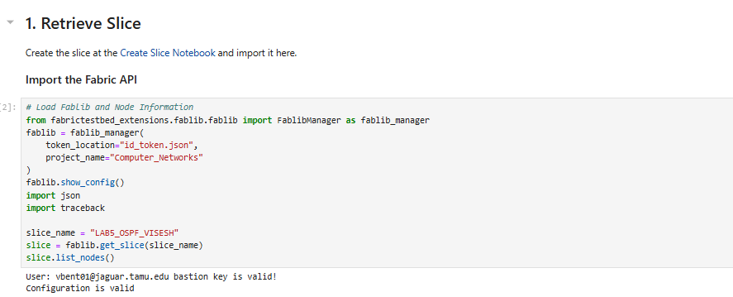
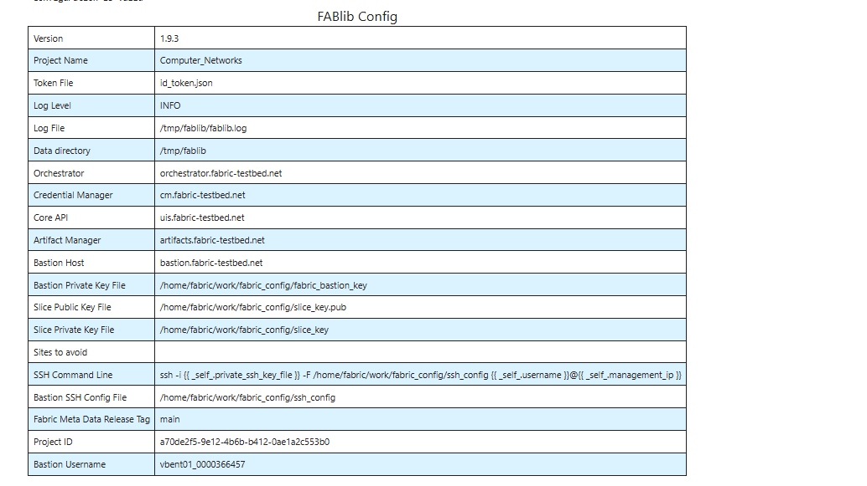
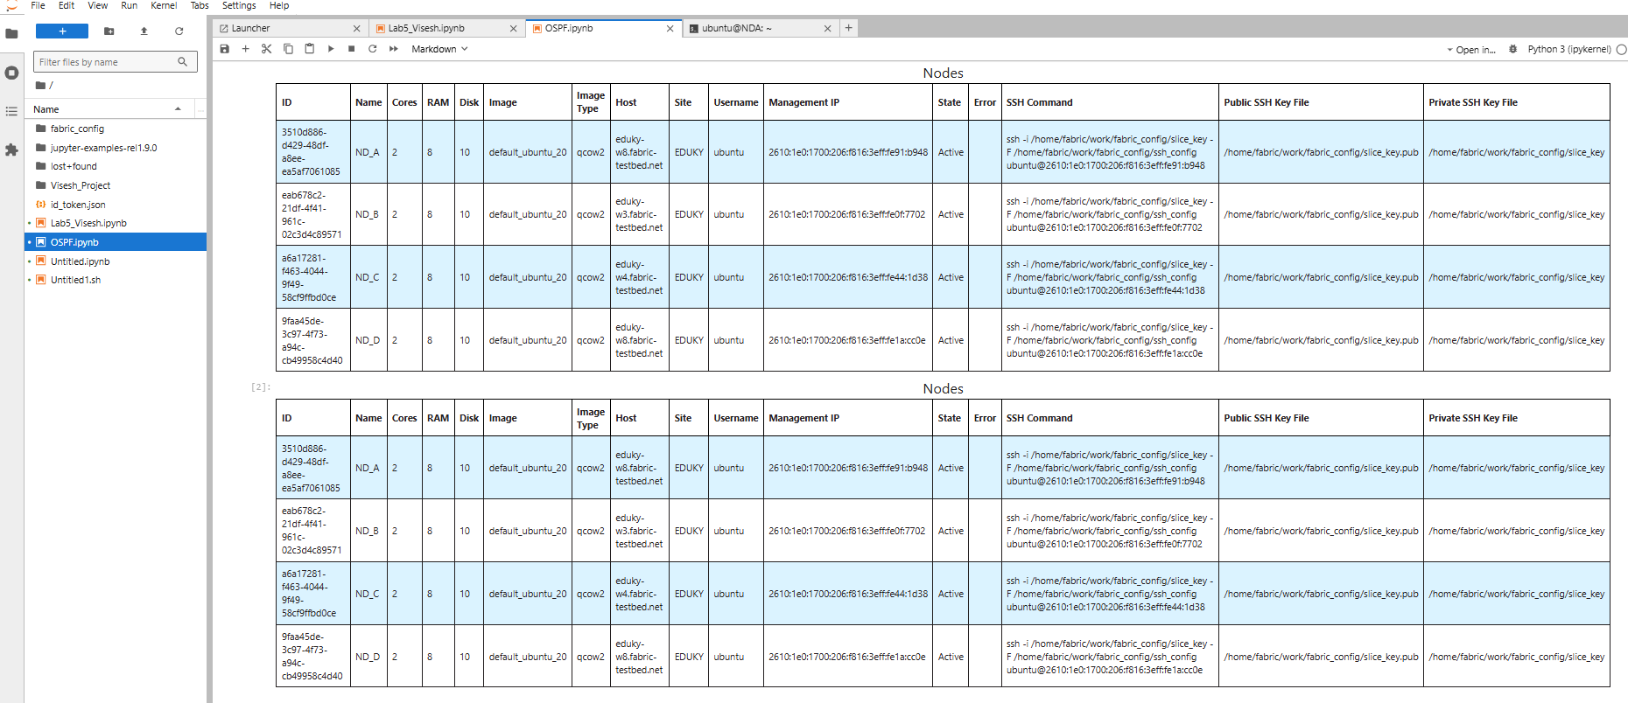

2. Guided Experiment (I followed these steps)
2.1 Router Interface
- Login to each node
- Open the Quagga shell Quagga provides an integrated user interface shell called vtysh, a cisco-like CLI, connecting to the underlying daemons (zebra and ospfd).
Open the shell on each node by typing:
sudo vtysh
- Look at the OSPF neighbors for a node by typing the following into a vtysh console:
show ip ospf neighbor
The output shows the status of neighbors including details of the connections, such as the Dead time, which indicates a countdown to refresh the connection.
- The routing table for a node can be seen by typing the following into a vtysh console:
show ip ospf route
This table shows how packets would be forwarded from the source to a given available destination.
- Exiting the console can be done by executing:
exit

Node A
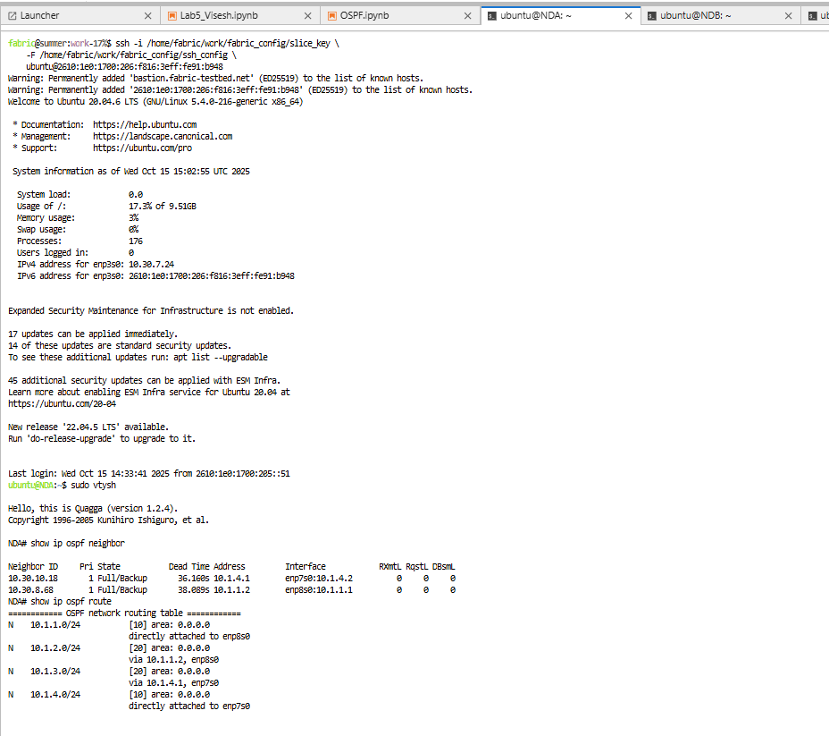
Node B
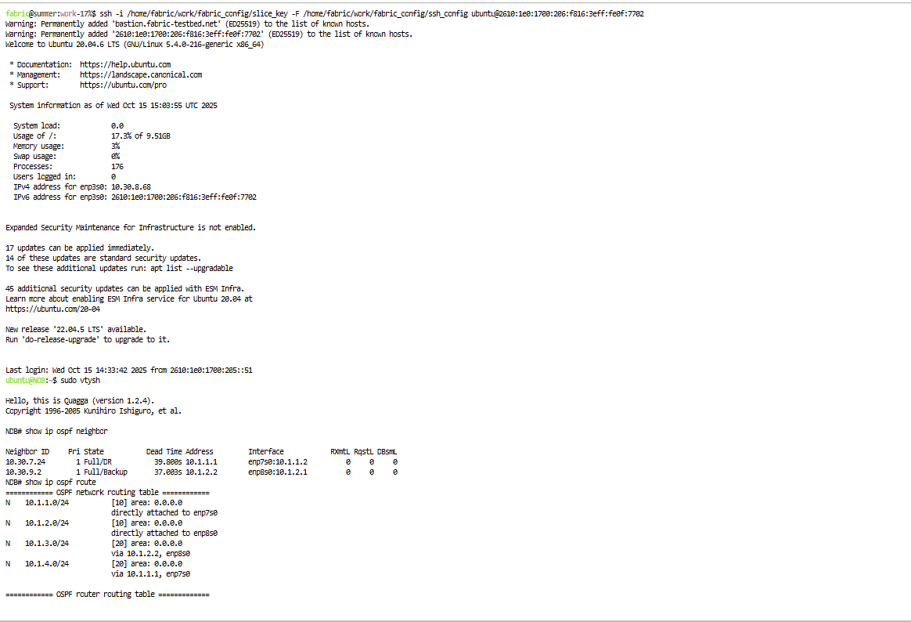

Node C
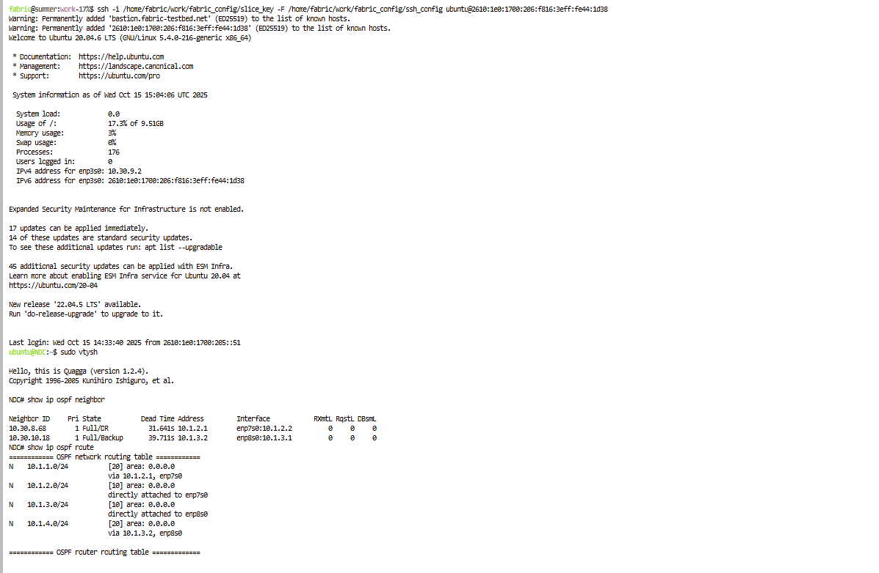

Node D
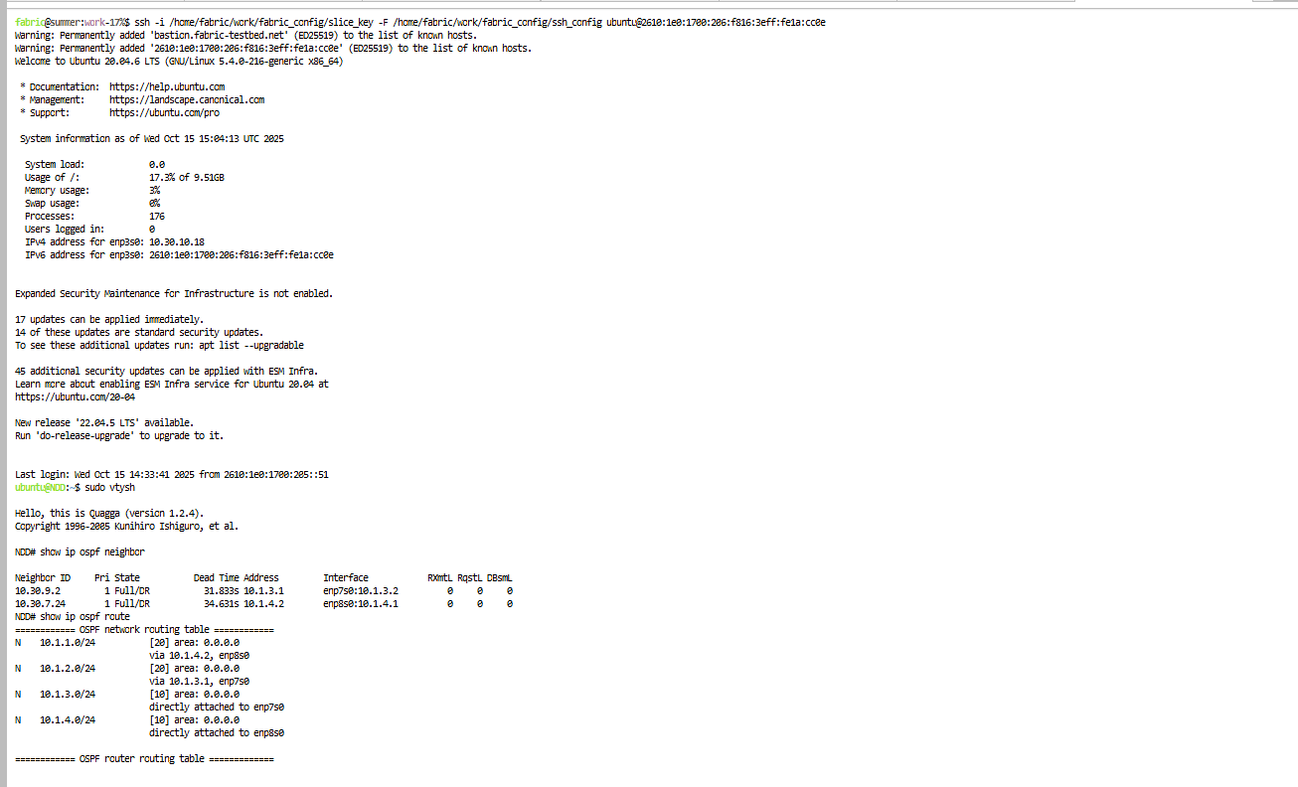

2.2 Dead Link (I followed these steps)
- Login to a node
- Show available interfaces with:
ip addr
- Take down one of the links (enp7s0 or enp87s0). Keep in mind the IP address associated:
sudo ip link set dev <interface> down
- Quickly switch back to vtysh shell and reissue:
show ip ospf neighbor
- Reissue the command multiple times and watch the Dead Time count down until the neighbor is removed from the table. The other link will also count down but resets when receiving a hello message.
- Exit the console and bring the interface back up by typing:
sudo ip link set dev <interface> up
- List the OSPF neighbors once more to see the link listed.

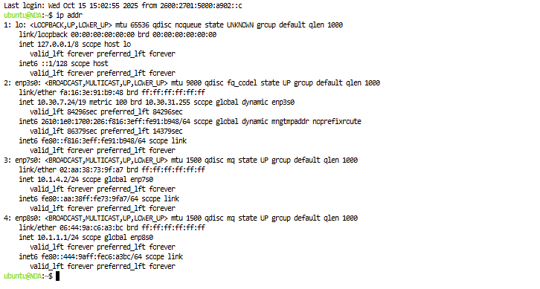
Took down enp7s0
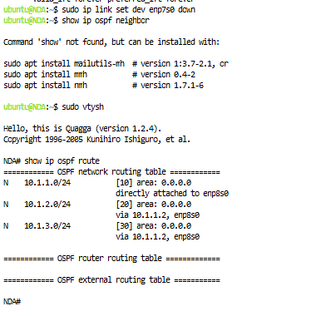

Brought it back up

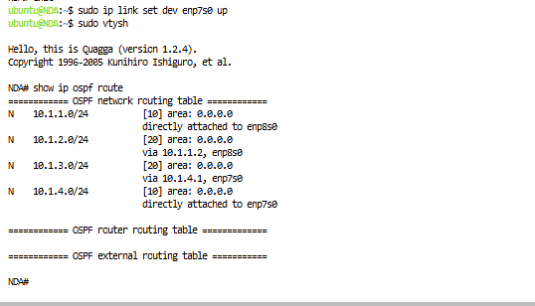
Brought the interface back up again
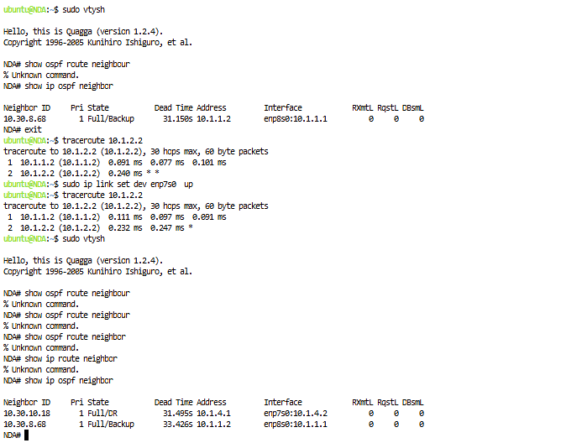
3.Assignment
Part 1
I started a continuous ping from Node A (10.1.1.1) to Node C (10.1.2.2) and then brought down the interface ND_B:enp7s0 using
sudo ip link set enp7s0 down
The ping stopped briefly as OSPF recalculated routes. After restoring the link with
sudo ip link set enp7s0 up
the ping resumed normally.
This shows OSPF can detect failures and reroute traffic automatically.
Part 2
To modify how fast OSPF detects link failures, I edited the configuration file /etc/quagga/ospfd.conf on every node.
Under each interface section, I added the following lines:
ip ospf hello-interval 2
ip ospf dead-interval 5
These settings reduce the hello interval to 2 seconds and the dead interval to 5 seconds.
After saving the file, I restarted the OSPF service with
sudo /etc/init.d/ospfd restart
and used vtysh to confirm the changes.
1. Default Dead Interval:
Before any changes, OSPF used a 10-second hello interval and a 40-second dead interval (four times the hello value). This meant that a neighbor would only be marked down after 40 seconds without receiving hello packets.
2. Effect After the Change:
With the new values, OSPF detected link failures much faster. In testing, routes reconverged in roughly 5 seconds instead of 35–40 seconds. The network recovered almost instantly after a link was restored, showing how shorter timers lead to quicker fault detection and reconnection.
3. Networks That Benefit from Shorter Intervals:
These settings work best in high-speed, low-latency environments such as data centers, backbone networks, or systems that require real-time communication.
In such networks, routers can handle more frequent hello messages without performance issues.
4. Drawbacks of Shorter Intervals:
Frequent hello packets slightly increase CPU usage and control traffic.
In large or unstable networks, this can also lead to false link failures if packets are delayed or lost, causing unnecessary route recalculations.

